Materials Required: Instructors will need a webcam and a YouTube account, which is free at www.youtube.com.
Instructions:
Record your video using your webcam and its related software—webcams usually come with basic, free recording software).
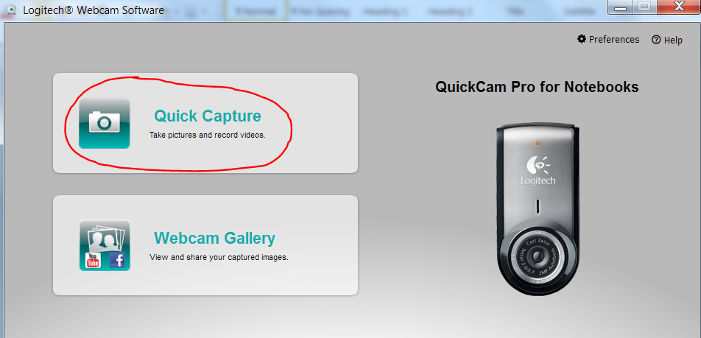
Upload the video to your YouTube account.
NOTE: I recommend setting the video options in YouTube such that users cannot rate or comment because these responses are unnecessary. Having the ability to rate or comment on the video could confuse students who have questions and need to take them to the appropriate space in the LMS to ensure the teacher’s response.
Blackboard allows user to “Create” new announcements. Within the announcement editor you can switch to an HTML view by clicking the < > icon.
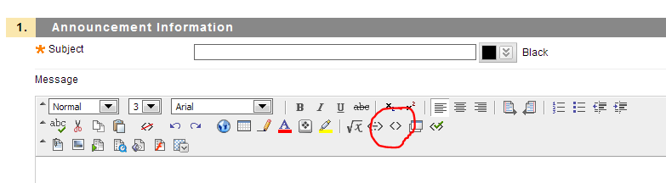
In YouTube, you can choose to “Share” your video. Selecting this choice gives you the option to “Embed”; at this point, you can cut and paste the HTML code provided by YouTube into the Blackboard announcement editor screen.
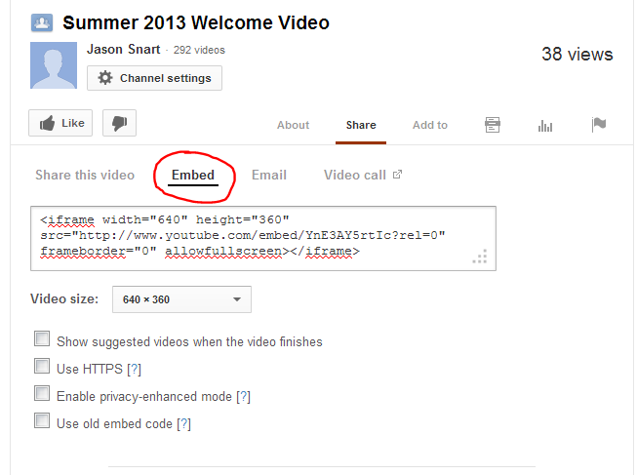

To finish the process, click “Submit” in Blackboard.
When students log in, they see new videos available to watch:
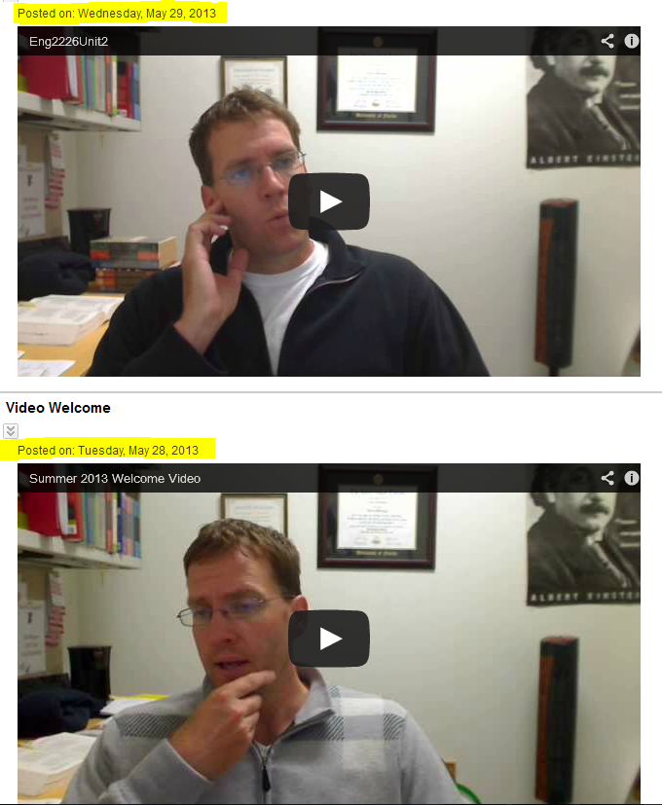

Note that YouTube gives you limited choice when it comes to picking the still image that is visible before a user hits the “Play” icon. I invariably end up with some real winners….

Additional Notes:
Something that I like about these videos is that they are relatively low-tech and fairly informal. I don’t script them before-hand, so if (or when) I say “um,” I just keep going. The result is me just talking to students as I would in the face-to-face environment. The informal approach certainly makes it easier for me, since I do not have to work through multiple takes or edit the video after it’s recorded. But I think the informal approach also may appeal to students since the point is to be there in front of them just as I would normally. So, if I forget things, have to look something up, say something silly….that’s all just part of being a real person for them.
The goal is ultimately to address part of what is stated in OWI Principle 11: “Online writing teachers and their institutions should develop personalized and interpersonal online communities to foster student success.” The informal welcome video is one way to make the online learning experience a little more personalized; it begins to create a sense of community for students, and hopefully it helps to foster student success by encouraging their engagement with the class.
A number of students have commented on how much they like the videos. For example, one student noted: “I found the videos that were uploaded to be very helpful because if the wording was confusing in the unit then the video helped clear up any confusion. It also made the class more personal because I could actually see what my professor was like” (Student Survey, Spring 2013, Introduction to Creative Writing). Yet another student commented that “The videos also made the class feel more like we are actually being taught in a class environment , by a real person, and not a computer” (Student Survey, Spring 2013, English Composition II). These kinds of spontaneous student remarks are signs that the videos help with achieving the sense of instructor presence for which I am aiming.

